Client Name:
Sam Green
Client Address:
1308 Peale St, Bryan, TX 77803
Phone Number:
979-220-5093

Distance from the Church:
1.6 miles – 5 minutes

Description of the work:
Construct a steps structure from the back porch to go down hill towards the shed at the bottom of the slope. Attach the steps to the side of the concrete porch and install handrail on one side of steps. The steps will not go all the way to the shed.

Line level is crucial for this project

Site Pictures

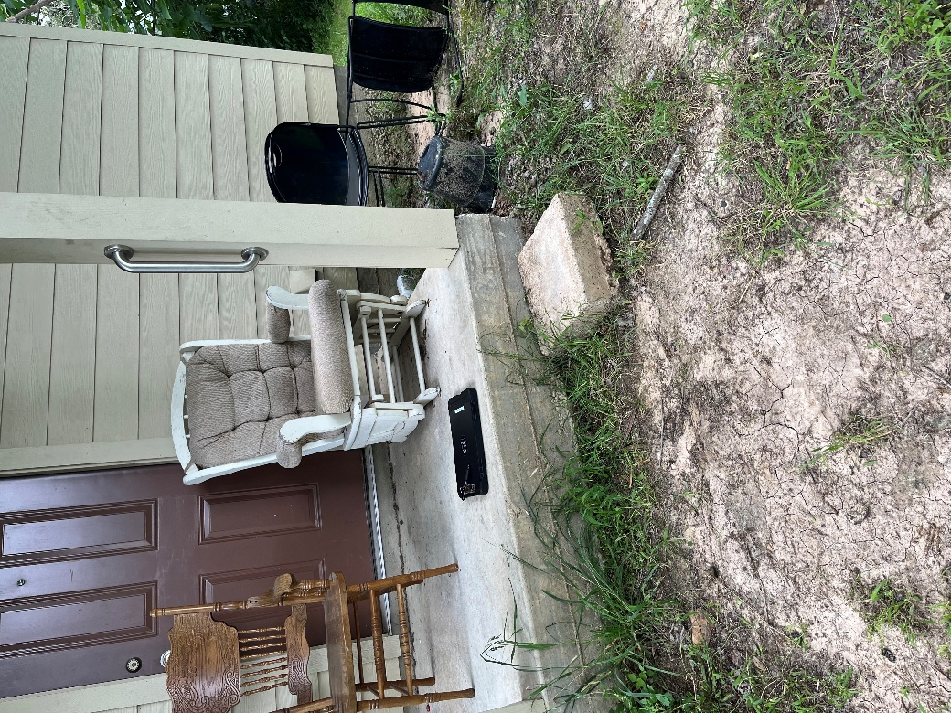
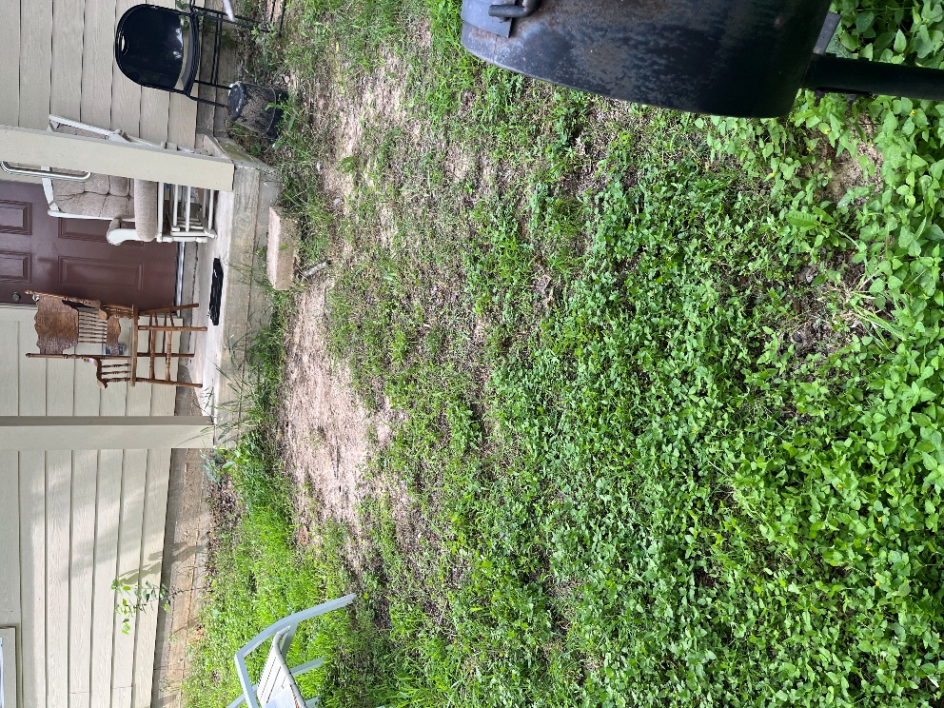
Rendered Project
“Build to site not to plan”
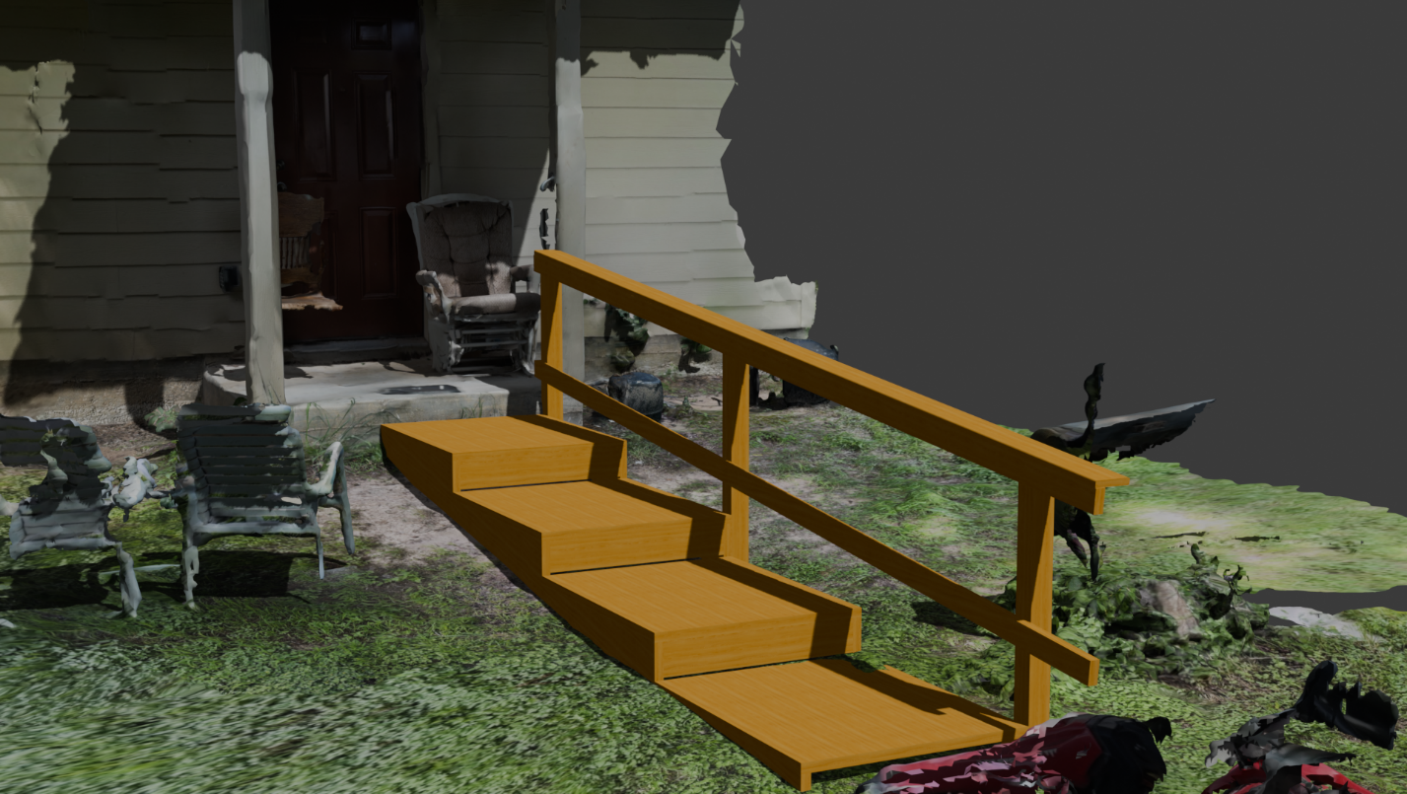
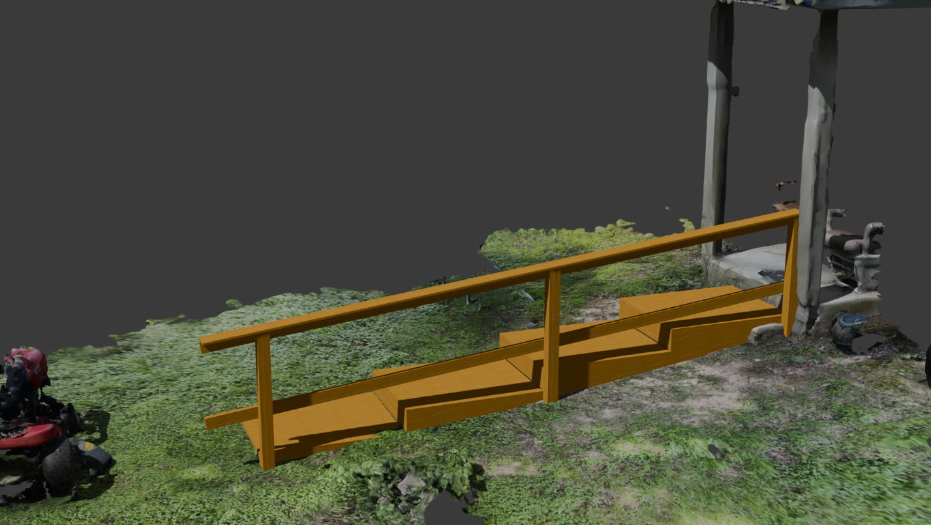
Building Notes
- Pray before you cut your 2x12s, they are expensive boards
- 6 pavers have been provided to create an even surface before the steps
- Discuss with the client about how the handrail should look, you have the material for both sides

